Collateral Web

Q4 2016 Enhancements Production Release Notes

Welcome to v2016.10.31.0001!

Main areas of focus in this Collateral Web production release include:

* FEMA Hyperlink for Flood Maps on the Buildings Panel
* Purchased Participations Secured by Chattel
* Lien Position Configurable by ACA
* Ability to Edit Loan Position from Collateral Analysis Screen
* Ability to Edit Partial Releases Before Scenario is Submitted
* Updated Real Estate Collateral to follow new IRS Requirements

FPI Credit Products

November 12, 2016



Table of Contents

Collateral Web 1

FEMA Hyperlink for Flood Maps **(FCE/YKE/AgC ONLY)** 2

Farm Credit East 2

Yankee 2

AgCountry 3

Lien Position Configurable by Association 4

Farm Credit East and Yankee 4

Ability to Edit Loan Position on Collateral Analysis Screen **(FCE/YKE ONLY)** 5

Ability to Edit Partial Releases Prior to Submission 6

Summary Level Partial Releases 6

Detail Level Partial Releases 7

New Collateral Cannot be Partially Released 8

Partial Releases of Zero Value 9

Purchased Participation Loans Secured by Chattel **(FCE/YKE ONLY)** 10

Updates to Real Estate Collateral for New IRS Requirements 11

Location 11

Primary Location (1098) 12

Business Rules for Invalid Address 13

Resolved Items 14

## FEMA Hyperlink for Flood Maps **(FCE/YKE/AgC ONLY)**

Previously in Desktop EmPOWER, a hyperlink was available in LOS that brought you to the FEMA Determination site. This hyperlink is now available in Collateral Web for Farm Credit East, Yankee, and AgCountry. Each association will be directed to the following sites:

* Farm Credit East: <http://www.interflood.com/>
* Yankee: <http://www.interflood.com/>
* AgCountry: [https://lender.floodapp.com](https://lender.floodapp.com/)

### Farm Credit East

In Farm Credit East, on the **Check All That Apply** panel, indicate that “The property includes buildings or improvements”. The **Search Flood Maps** hyperlink will then appear on the **Buildings** panel.

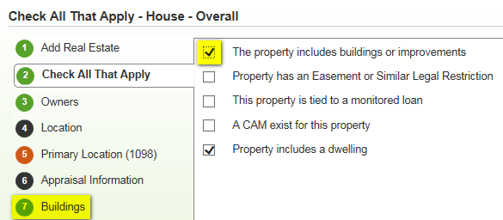

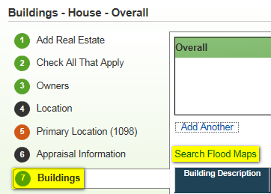

### Yankee

In Yankee, the **Search Flood Maps** hyperlink will appear on the **Buildings** panel.

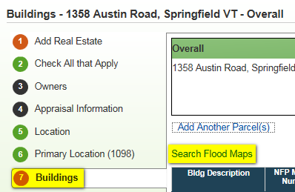

### AgCountry

In AgCountry, **Search Flood Maps** will appear on the **Buildings & Improvements** panel.

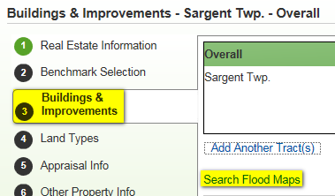

## Lien Position Configurable by Association

Whether lien positioning is an active feature of Collateral Web is now **configurable by association**.

**Farm Credit East** and **Yankee** have elected to configure lien positioning **OFF**. All other associations will continue with lien positioning configured ON.

### Farm Credit East and Yankee

In Farm Credit East and Yankee, **Collateral Web will no longer default lien position**. Previously, in a scenario with multiple security documents, linking collateral to an existing security document would default the lien as “2nd position”. You would then need to change it back to 1st position.

When collateral is linked, **lien position will no longer be displayed**. This change will prevent you from having to continually update lien position for each collateral relationship, resulting in greater productivity and efficiency.

In the example below, linking the Real Estate to Security Document 10/06/2016 (*on the left*) will display the Smart Link Wizard without the lien position. Select **Save** to finishing linking the collateral.

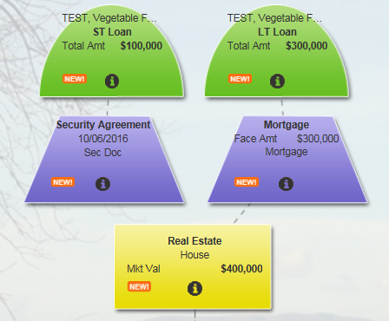 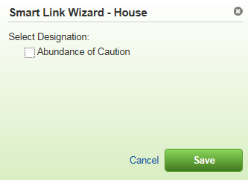

## Ability to Edit Loan Position on Collateral Analysis Screen **(FCE/YKE ONLY)**

If lien positioning is configured OFF for your association, you can now edit **loan position** from the **Collateral Analysis** screen. Previously, it was a requirement for security documents to be linked to collateral when setting loan position. However, security documents do not factor into the position each **loan** is in.

This enhancement will allow you to stay on the Collateral Analysis grid. You no longer have to navigate to the Collateral View screen to make these changes.

To edit loan position on the Collateral Analysis grid, hover your cursor on the loan you would like to edit. This will display the **Update Relationship** menu. Selecting the menu will display the screen to edit loan position. Select **Save** to complete.

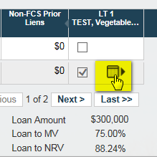 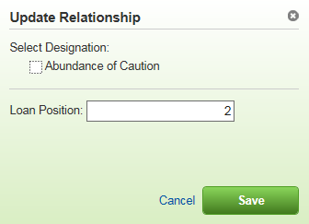

Any changes made to loan position will display on the Collateral Analysis grid.

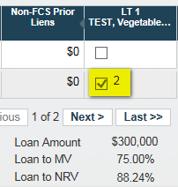

## Ability to Edit Partial Releases Prior to Submission

Previously, once a partial release was saved, it could not be modified. To make any changes, the collateral would have to be deleted and re-entered.

Now, if you have not yet submitted your scenario, you can click into the **Partial Release** **History** tab on the Partial Release Smart Data Wizard and edit the release information.

Under the **Partial Release History** tab, every release will be displayed. The **edit** hyperlink appears to the left of each release. You may also **delete** summary level partial releases.

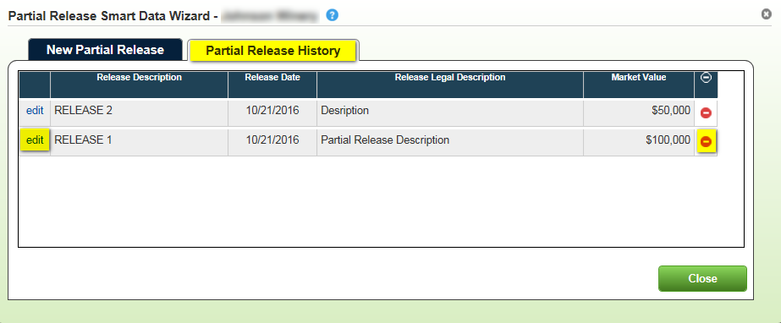

### Summary Level Partial Releases

For ***summary*** level partial releases, selecting **edit** allows you to make changes to the **Release Description, Release Date, Release Legal Description,** and **Market Value being released.**

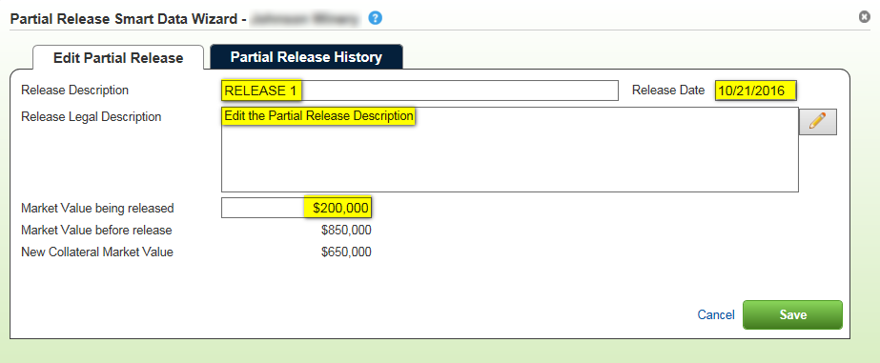

### Detail Level Partial Releases

For ***detail*** level partial releases, you cannot enter a specific market value as you can at the summary level. Selecting a detail record for partial release will release the **entire value of the detail**.

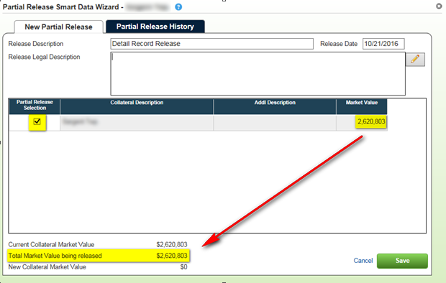

If you want to release only a **portion of a detail** record:

1. Create an additional detail record for the amount that will **NOT** be released.
   * Example: The value of the collateral after the partial release should equal $1,000,000

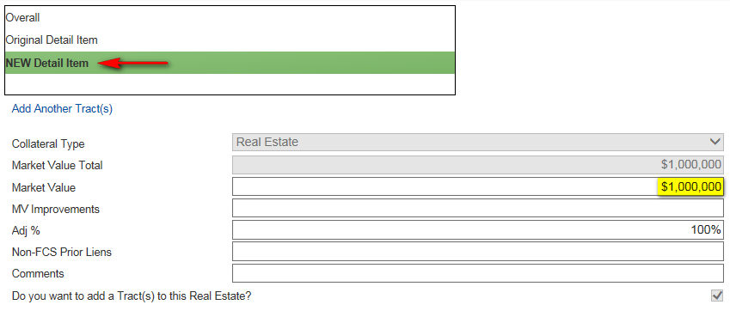

1. Perform a partial release of the **original** detail record:

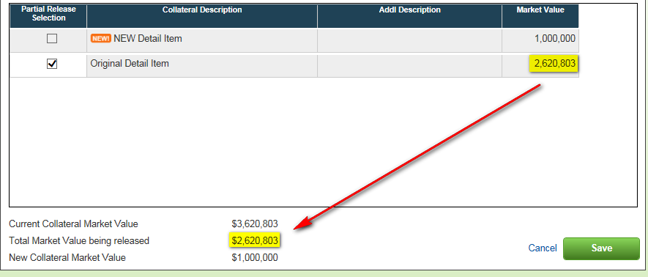

### New Collateral Cannot be Partially Released

For **new collateral** or **new detail records** under existing collateral, you will **not** be able to do a partial release. On the detail items menu, the Partial Release Selection will be grayed out. You will not be able to select the checkbox under **Partial Release Selection** for a detail record that was created as part of this scenario.

An orange **NEW!** icon will appear on the new detail record rows as a notification.

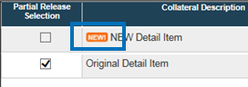

**REMINDER:** On new collateral objects created as part of this scenario, Partial Release will **not** appear as an option on the drop-down menu.

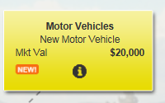

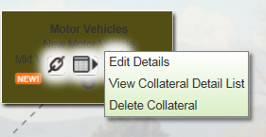

### Partial Releases of Zero Value

In the event that you want to release a portion of collateral but do not want to release any **value** associated with it, you can now **enter $0 as the Market Value** being released.

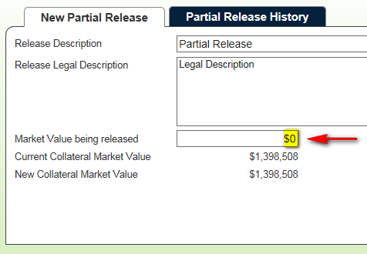

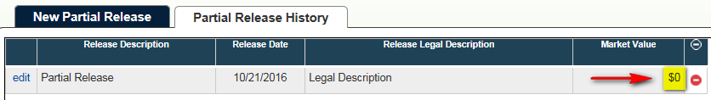

## Purchased Participation Loans Secured by Chattel **(FCE/YKE ONLY)**

For Farm Credit East and Yankee, **purchased participations** are categorized as **long-term loans** in Collateral Web.

Normally, chattel is not factored into the L/MV% for a long-term loan. With this update, **chattel will now be factored into the calculation for long-term purchased participations**.

In the below example, the $2,000,000 purchased partifipation is a long-term loan secured by $10,000,000 of chattel. The L/MV% is calculated as 20.00%.

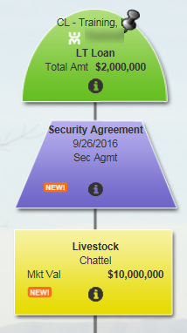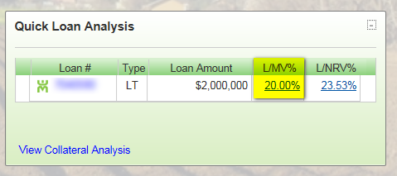

Using this same example, if the long-term loan is **not** a purchased participation loan, then the L/MV% will continue to be calculated as zero.

## Updates to Real Estate Collateral for New IRS Requirements

For the 2016 tax year, the IRS has made some changes to the 1098 form as relates to reporting addresses on collateral securing real estate. These changes are specific to **Box 7 - Address of Property Securing Mortgage**, **Box 8 -** **Property Address (If Different from Payer’s/Borrower’s Address)**, and **Box 9 - Property Description (If No Address Available)** on the 1098 form. To view the full IRS Instructions for Form 1098, click [here](https://www.irs.gov/instructions/i1098/ar02.html).

As a result, changes have been made the **Location** panel on the **Real Estate Smart Data Wizard** to help capture the information that the IRS now requires.

### Location

On the **Location** panel, all addresses currently available in EmPOWER for all of the customer’s **groups** will appear in the **Existing Addresses** box.The names of any customers associated with that address will show up in parentheses after the zip code. If there are multiple customers associated, they will be separated by a semi-colon.

If you see the address you need in the Existing Addresses list, select the address, and then click the **Add Location w/ Selected Address** hyperlink.

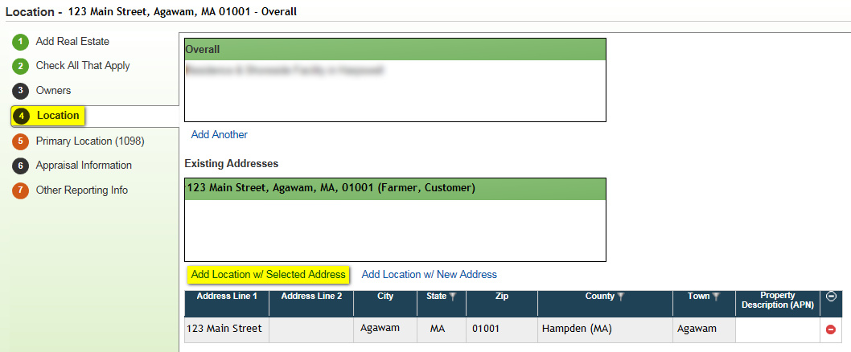

Selecting an address from the Existing Addresses box **creates a link** between Collateral Web and the address in desktop EmPOWER CRM.

Addresses selected via the Existing Addresses box will be **read-only rows** in the location grid. Changes to existing addresses can only be made in desktop EmPOWER.

THERE IS CURRENTLY **NO WARNING** IN EmPOWER IF YOU CHANGE AN ADDRESS LINKED TO COLLATERAL. Please be cautious as you make address changes.

A **future enhancement** in desktop EmPOWER will provide a warning that the address is linked to collateral.

If this particular piece of collateral’s address is not already an existing address, select **Add Location w/ New Address**. A new blank row will populate in the location grid.

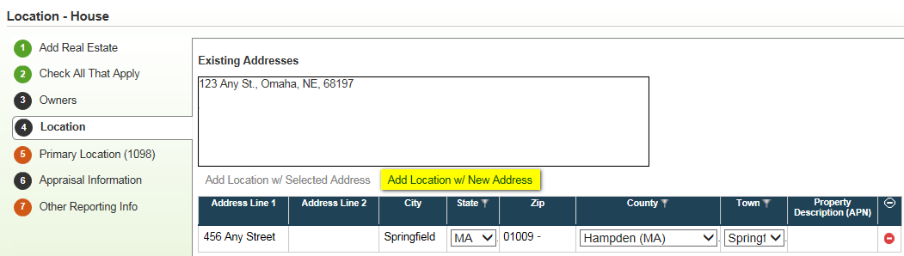

Enter **either** a valid mailing address (**Address Line 1, City, State,** and **Zip**), **OR**, enter the **Property Description (APN)** with the **State** and **County** in which the piece of real estate is located.

### Primary Location (1098)

For all associations ***except*** Northwest, you will also see a new panel called **Primary Location (1098)**. This panel is used to select the location that will be used on the 1098 form for this collateral object.

The panel pulls all locations from both the **Overall** and any **detail** rows on the Location panel. The radio button to select the **Primary for 1098** will default to the first available location in this list. You may change the selection using the radio button.

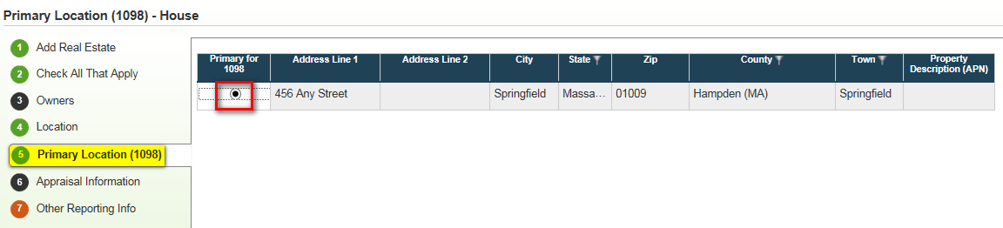

In **Northwest ONLY**, the **Primary for 1098** radio button is included in the grid on the **Location** panel.

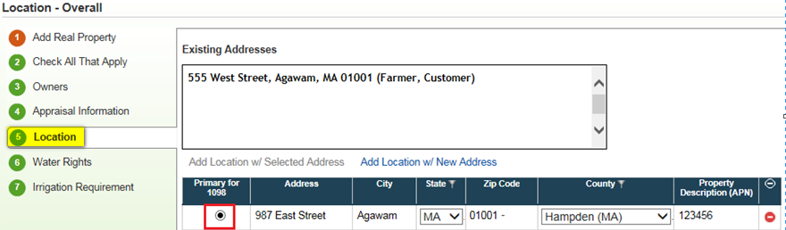

In some cases, a **single collateral object** may have **multiple detail records** securing **multiple loans**. Each detail record may have a different primary address.

In this situation, you should **split** out the individual detail records from that collateral using a **Split Tract**. Once you have done so, you can set a different primary address for each collateral object.

### Business Rules for Invalid Address

You **must fill out** the following fields on the **Location** panel to **pass all Business Rules**:

* Address Line 1 (Address), City, State and Zip Code

**OR**

* Property Description (APN), County, and State

If you are **missing** any of the above fields for the location row set as the **Primary for 1098**, you will have an **invalid** address.

If you attempt to **submit or validate** a scenario with an invalid address for the primary location for the 1098, or if you do not include any address, you will receive the following **soft** error:

“The Primary Location for Real Property Collateral ‘House’ does not have either a valid mailing address, or a Property Description with County and State information. This is required for IRS reporting.”

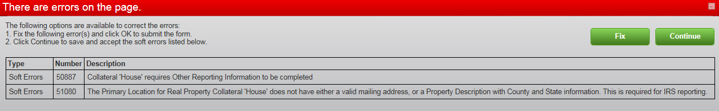

**You will still be able to submit the scenario and book loans, as needed. HOWEVER, we strongly recommend that you enter all collateral address information before submitting.**

# Resolved Items

| TFS # | Summary Description | Detail Description / Resolution | INC # | FCE | YNK | NW | FCW | AgC |
| --- | --- | --- | --- | --- | --- | --- | --- | --- |
| 89509 | 2016 Tax Season IRS Requirements for Real Estate Collateral | On the Location panel, you now have the ability to link to Exisitng Addresses from desktop EmPOWER, or to add new addresses. You will be required to enter either a valid mailing address, OR the Property Description (APN) with the County and State in which the real estate is located. In addition, there is a new panel, Primary Location (1098), to indicate which address is the primary for Tax Form 1098. |  | X | X | X | X | X |
| 92340 | Add FEMA Hyperlink for flood maps | FCE, YNK and AgC ONLY – FEMA Hyperlink for flood maps will appear on Buildings Panel. You will be forwarded to the appropriate website to search flood maps. |  | X | X |  |  | X |
| 92354 | Purchased participations secured by chattel | FCE and YNK ONLY - For Farm Credit East and Yankee, purchased participations are categorized as long-term loans in Collateral Web. Normally, chattel is not factored into the L/MV% for a long-term loan. With this update, chattel will now be factored into the calculation for long-term purchased participations. |  | X | X |  |  |  |
| 92360 | Lien position configurable by association | Whether or not lien positioning is an active feature of Collateral Web is now configurable by association. Yankee and Farm Credit East have elected to configure lien positioning OFF. All other associations will leave lien positioning configured ON. |  | X | X | X | X | X |
| 92363 | Ability to edit loan position from Collateral Analysis screen | FCE and YNK ONLY – If lien positioning is configured OFF for an association, you now have the ability to edit the loan position from the Collateral Analysis screen, instead of just the Collateral View screen. When you hover over the loan you wish to edit, the “Update Relationship” menu will appear. Use this menu to edit the loan position and AOC from the Collateral Analysis screen. |  | X | X |  |  |  |
| 92961 | Partial Releases editable | You may now edit Partial Release prior to submitting a scenario. On the Partial Release History tab, you can edit Release Description, Release Legal Description, Release Date, and Market Value being released (summary level). You will not be able to edit the value for detail level releases. |  | X | X | X | X | X |
| 96782 | Partial Releases can have a value of zero | For summary level partial releases, you may now enter $0.00 as the market value being released. This will help keep track of legal information associated with releases of zero value. |  | X | X | X | X | X |
| 96859 | Radio button for 1098 on Location panel | NW ONLY – Since Northwest did not configure the ability to add detail on the Location panel, there is no need to have a separate panel to set the primary location to send to the 1098 form. The radio button to indicate the primary address for the 1098 will appear on the Location panel for Northwest. |  |  |  | X |  |  |
| 96868 | Identify customers name in Existing Addresses of Location panel | For each address that is pulled from EmPower, the customer’s name will appear in parenthesis next to each address. If there are multiple customers associated with a particular address, they will be separated by a semi-colon. |  | X | X | X | X | X |